Carambola
The “Starfruit”

Outlook as a potential commercial crop: Carambola can be grown along the western side of San Diego County and the coastal Southern California counties, perhaps as far north as San Luis Obispo County (but only in frost-free locations). In 2009 we were aware of only one small commercial grower (in San Diego County); this grower had only 14 trees. As the only grower, he received a very high price for his fruit and this price will, of course, be reduced as more growers come into the market. However, as a locally grown fruit, carambola has a great potential because it is a very unusual and beautiful fruit; cut in cross section it is the shape of a five point star and looks great in fruit salads. It is not drought tolerant and cannot be grown in areas that are subject to frost. It is a slow growing small tree that has a short trunk with a very bushy multi-branched canopy (suitable for hedgerow production). The reputation of the fruit as far as having a ‘bland’ taste may be changing because new cultivars with higher sugar content have been identified by the University of Florida and these cultivars are going to be imported into California in during 2010.

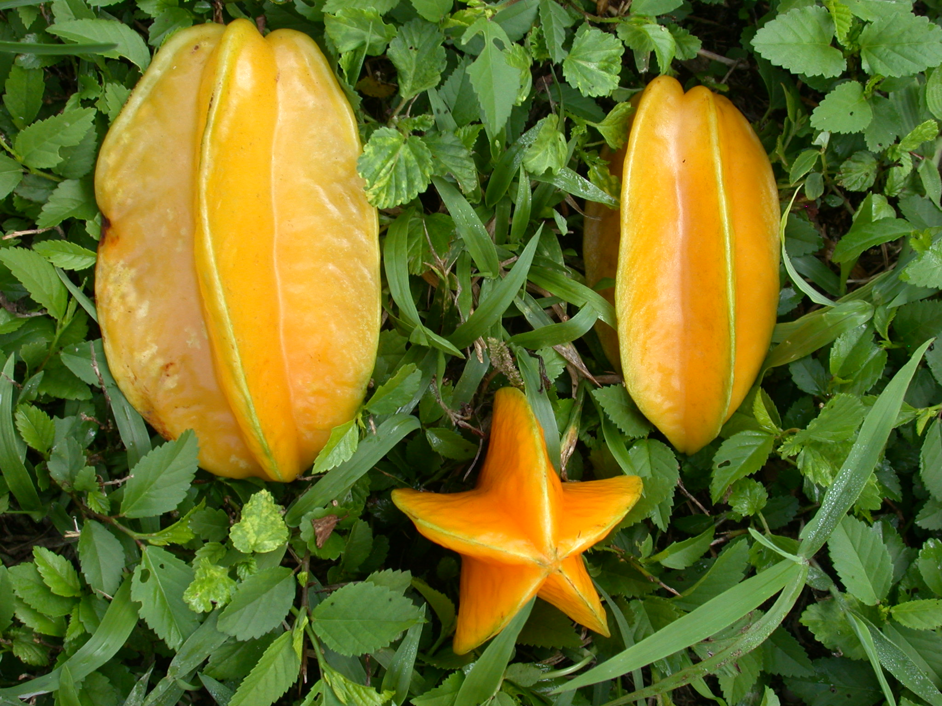

Description:

Scientific name: Averrhoa carambola L. It is in the family Oxalidaceae. (Note: carambola fruit contains oxalic acid and may cause a decline in renal function for people with kidney disease. People with kidney disease should probably not eat this fruit.)

Related species: bilimbi (Averrhoa bilimbi L.)

Origin and History: The origin of the fruit is in Southeast Asia and has been grown in Thailand, Malaysia, and Sri Lanka for centuries. The fruit was introduced into Florida in the late 1800’s but was not developed into a commercial crop until the 1970’s when sweeter (less tart) varieties were developed. Recently even sweeter varieties from Thailand, Taiwan and Malaysia have been introduced into Florida.

Distribution in the U.S.: The fruit is only grown commercially in southern Florida and Hawaii It is not yet a commercial crop in California, however it is grown as a plant of interest by hobbyists in southern California..

Adaptation: Carambola can tolerate temperatures as low as 27 F for short periods, but young plants can be killed at 32 F. The trees cannot tolerate flooding or hot dry winds for any length of time. The trees do not tolerate drought conditions for very long.

Description and Cultivars

Botany: Carambola is a slow-growing, evergreen tree with a short trunk; the tree is highly branched. It has been reported in Florida that, if left un-pruned, the tree can reach heights of 22-33 ft, but this has not been observed in California. The leaves are conpound, 6-10 inches long arranged alternately on the branches; leaflets are 1.5 -3.5 inches long.

Flowers are perfect, pink to lavender in color, 3/8 inch in diameter and borne in clusters in axils of leaves on young branches. Occasionally there may be bloom on older wood. Often there will be several flushes of bloom during the year.

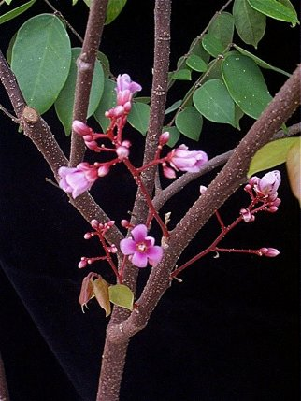
http://www.plantoftheweek.org/week313.shtml

The fruit are star-shaped in cross section with 5 prominent longitudinal ribs. The fruit is considered a berry with five cells (occasionally 4 or 6 cells). The skin is thin, light to dark yellow and smooth with a waxy cuticle. The fruit have about 10-12 seeds which are edible. The flesh is crisp and juicy without fiber. 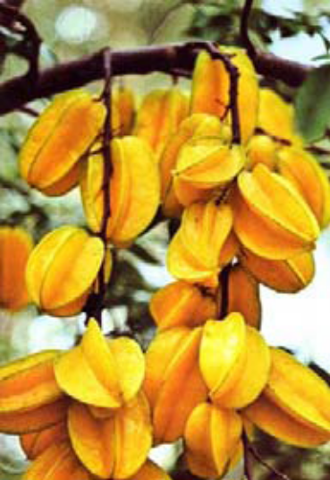

Cultivars: There are sour and sweet cultivars and the main complaint concerning carambola is that it is not sweet enough (some are described as insipid). With breeding and selection the sweetness has been improving over the years and the following cultivars have been identified by Dr. Jonathan Crane (University of Florida, Homestead) as the selections that are sweet with good flavor. Descriptions for most are from CRFG Fruit Facts; descriptions for Kary and Lara are from J. Crane.

Arkin (Origin: Florida) Uniform fruit 4-5 inches long. Bright yellow to yellow-orange. Bears December to March in California. The leading commercial cultivar.

Fwang Tung (Origin: Thailand) Fruit 5-8 inches long. Pale yellow skin and flesh. Very sweet and juicy, firm flesh with few seeds. Beautiful star shape when cut in slices.

Kajang (Origin: Hawaii). Fruit 4-5 inches long. Bright yellow skin and flesh. Sweet, juicy, firm flesh with few seeds. Beautiful star shape when cut into slices.

Kary (Origin: Hawaii). Medium to large fruit, yellow to orange skin and flesh, Very good quality and flavor.

Lara (Origin: Florida). Medium to large fruit. Yellow to orange skin and flesh. Good quality and flavor.

Sri Kembangan (Origin: Malaysia). Elongated pointed fruit 5-6 inches long. Bright yellow-orange skin and flesh. Juicy, firm flesh with few seeds. Flavor rich and sweet, excellent dessert quality.

Pollination: Some cultivars such as ‘Arkin’, ‘Fwang Tung’ and ‘Golden Star’ do not require cross-pollination when planted in large blocks. Others appear to differentiate according to whether the cultivar has short styles or long styles in the flowers. For instance, if a cultivar has short styles, fruit set and yields will be improved by planting them near a cultivar with long styles.

Culture

Propagation: Seeds lose viability within a few days of removal from the fruit, therefore seeds should be planted immediately. Cultivars are propagated by grafting onto seedling rootstocks by veneer grafting or chip budding during the time of most active growth. Actively growing healthy carambola seedlings of ¼ inch diameter are best. Graftwood is best taken from mature twigs on which leaves are present and which the buds are just beginning to grow. Another method is to remove leaves 3-4 days ahead of grafting which stimulates the buds to begin growing. Air layering has not proven successful.

Fertilizer: For a young tree, the University of Florida recommends an application of ¼ to ½ lb of mixed fertilizer (N-P-K) applied every 30-60 days. They suggest a fertilizer mixture of 6-8% nitrogen, 2-4% available phosphoric acid and 6-8% potash. As the tree matures the fertilizer rate should increase 1 to 5 lbs, 4 to 6 times a year. They also suggest application of iron chelate and magnesium to the soil and 4-6 application of minor element spray, but that may not be necessary under California conditions.

Irrigation: Carambola is not a drought-tolerant plant. It requires regular watering during summer months and watering in the winter during dry periods. An irrigation trial has not been conducted in California to determine the crop coefficient for use with CIMIS.

Salinity: Carambola is not tolerant of saline water. The wells producing highly saline water would not be suitable for this crop. Colorado River water (our normal district water) would be suitable.

Pruning: The University of Florida provides the following interesting comments concerning pruning:
“During the first 1 to 2 years after planting, young trees should be pruned by tipping shoots in excess of 2 to 3 ft to increase branching. If desired, trees may be trained to a modified central leader or open center configuration. Mature trees may be selectively pruned to maintain trees at 6 to 12 ft in height. Selectively removing a few upper limbs back to their origins (crotches) each year will help prevent to the loss of the lower tree canopy due to shading by the upper canopy. In addition, maintaining a smaller tree facilitates tree care and fruit harvest, makes it easier to spray the tree, and greatly reduces possible storm damage. Do not remove lower tree branches.

“Pruning to produce off-season fruit. Carambola trees are unique in that once a shoot and limb develop the ability to flower, they can flower repeatedly. Shoots gain the ability to flower after about 3 months. Pruning the willow-like long shoots (“whips”) or selecting a small diameter limb and removing all the lateral shoots from this limb to their bases will induce flowering in about 21 days and fruit approximately 70-80 days later. Pruning during August may result in fruit during October. Pruning during November-December may result in fruit during February-April or June. This delay in fruit production is because cool temperatures during the fall and winter may prevent fruit set during January to March; however, generally the shoots will continue to flower until fruit is set.

“Flowering and fruiting may also be induced on whips by bending them from an upright position to a lateral position, clipping off the last 12 to 18 inches of growth, and clipping the leaves off but leaving a small (1/3 inch) piece of the petiole (leaf stem).

“Removing fruit to produce off-season fruit. Removing young fruit from trees during November-December will help to retain carambola leaves on the tree and may result in early spring flowering and fruit in June. Removing young fruit along with selective pruning described previously may induce flowering and off-season fruit production.”

Production and Harvest:

Fruit will not gain more sugar after harvest from the tree. Fruit are best harvested when yellow color develops in the furrow between the ridges and the ridges are green. Fruit may be stored in plastic bags in the refrigerator for up to 21 days.

Fruit are usually consumed as an addition to fruit salads. They are crisp and juicy and are excellent when eaten out of hand. They are also used wines and jellies and can be
canned, or preserved as dried fruit. 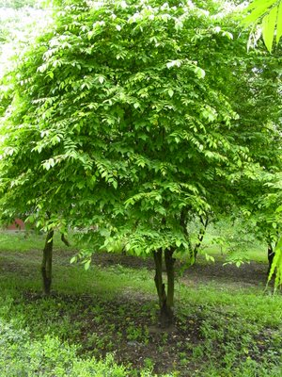
http://www.bijlmakers.com/fruits/starfruit.htm

